Day14
2 July 2025
Moahmmed Arsalain
mobarsal@amazon.com

Day 14 - 02th July 2025

Task 1:

Create a custom node , add elements to it and traverse it..

Task 2 👍
What do you understand by traversing elements in a linked list.

Task 3:

Create a Circular Linked list using Task 1 Singly linked list.

Task 9:

What are the methods of the stack class
Stack.pop
Stack.push()
Stack.search()
Stack.get()
Stack.empty()
Stack.peak()
Stack.capacity
Stack.remove()

Task 10:

What are the common operations in Queues

Enqueue:
Dequeue:
Peek:
isEmpty:
isFull:
Size:

What is the difference between recursion and iteration
Recursion :“A function that solves a small part of the problem and then calls itself to handle the rest.” Eg: Factorial & Fibnocci serieses
Iteration : “Doing something over and over again using a loop.” Eg : for , while loops

Create a Circular Linked list using Task 1 Singly linked list.

class Node {

int value;
Node nextNode;

public Node(int value) {
this.value = value;
}
}

public class CircularLinkedList {
// if the list is empty
private Node head = null;
private Node tail = null;

// …..
}

public void addNode(int value) {
Node newNode = new Node(value);

if (head == null) {
head = newNode;
} else {
tail.nextNode = newNode;
}

tail = newNode;
tail.nextNode = head;
}

private CircularLinkedList createCircularLinkedList() {
CircularLinkedList cll = new CircularLinkedList();

cll.addNode(13);
cll.addNode(7);
cll.addNode(24);
cll.addNode(1);
cll.addNode(8);
cll.addNode(37);
cll.addNode(46);

return cll;
}
public boolean containsNode(int searchValue) {
Node currentNode = head;

if (head == null) {
return false;
} else {
do {
if (currentNode.value == searchValue) {
return true;
}
currentNode = currentNode.nextNode;
} while (currentNode != head);
return false;
}
}

public void deleteNode(int valueToDelete) {
Node currentNode = head;
if (head == null) { // the list is empty
return;
}
do {
Node nextNode = currentNode.nextNode;
if (nextNode.value == valueToDelete) {
if (tail == head) { // the list has only one single element
head = null;
tail = null;
} else {
currentNode.nextNode = nextNode.nextNode;
if (head == nextNode) { //we're deleting the head
head = head.nextNode;
}
if (tail == nextNode) { //we're deleting the tail
tail = currentNode;
}
}
break;
}
currentNode = nextNode;
} while (currentNode != head);
}

Stacks

Collection (interface ) ===> List (interface) ⇒ Vector class ===> Stacks (class)

Hierarchy of stack class -

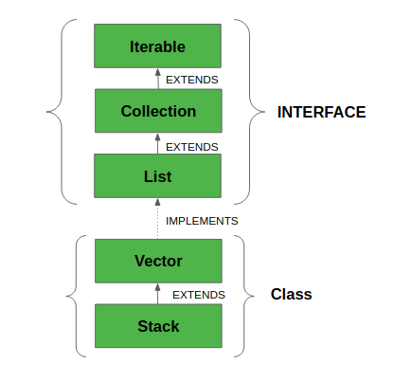

Task 4 :

Stacks

Create a code to implement a stack
12.42 – plz complete..

import java.util.Stack;
class Ds_Stack_Push {
public static void main(String[] args) {
Stack<String> names= new Stack<>();

names.push("Prasunamba");
names.push("Meher");
names.push(".MK");

System.out.println("Stack of names: " + names);
}
}

Task 5:

Create a stack and pop the element also print the popped element.

12.50 plz complete

import java.util.Stack;
class Ds_Stack_Pop {
public static void main(String[] args) {
Stack<String> names= new Stack<>();

names.push("Prasunamba");
names.push("Meher");
names.push(".MK");

System.out.println("before deletion ");
System.out.println("Stack of names: " + names);

System.out.println("after deletion ");
String dummy = names.pop();

System.out.println("Stack of names: " + names);
System.out.println("deleted element is "+ dummy);
}
}

Task 6:

Find an element in the stack and display the position

Hint 👍
Int position = names.search(“value”);

import java.util.Stack;
class Ds_Stack_SearchPosition {
public static void main(String[] args) {
Stack<String> names= new Stack<>();

names.push("Prasunamba");
names.push("Meher");
names.push(".MK");

System.out.println("Stack of names: " + names);

String Val = "Meher";
int position = names.search(Val);

System.out.println("the searched value is at position " + position);
}
}

Task 7:

Peek the element and print it ..

import java.util.Stack;
class Ds_Stack_Peek {
public static void main(String[] args) {
Stack<String> names= new Stack<>();

names.push("Prasunamba");
names.push("Meher");
names.push(".MK");

System.out.println("Stack of names: " + names);

String topElement = names.peek();
System.out.println("The top element (without removal); "+ topElement);

System.out.println("Stack of names after peek operation " + names);
}
}

Task 8:

Check if the stack is empty or not?

import java.util.Stack;

public class Ds_Stack_Empty {
public static void main(String[] args) {
Stack<String> names = new Stack<>();
System.out.println("Is the stack empty? " + names.empty());

names.push("Prasunamba");
names.push("Meher");

System.out.println("Is the stack empty? " + names.empty());

while (!names.empty()){
System.out.println("Popped: " + names.pop());
}

System.out.println("Is the stack empty? " + names.empty());
}
}

Task 9:

What are the methods of the stack class

14.47 to 14.51 to 14.55

16 pax done 14.54

Queues

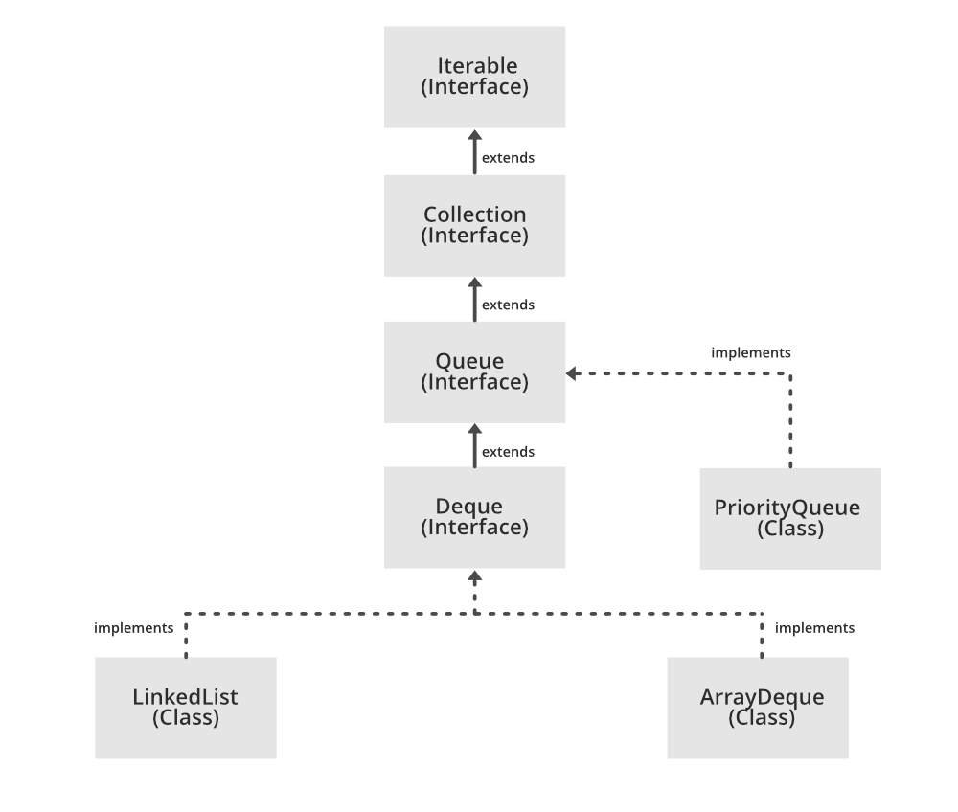

Task 10:

What are the common operations in Queues

Task 11:

Wap to create a queue with custom methods
Is empty ()
Is full()
Enque
Deque
Peek
display()

15.40 to 15.52 to 16.34
8 pax done @ 16.34

public class Queue {
int queueLength = 3;
int items[] = new int[queueLength];
int front = -1;
int back = -1;

void enQueue(int itemValue) {
if(isFull()){
System.out.println("Queue is full");
} else if(front == -1 && back == -1){
front = back = 0;
items[back] = itemValue;
} else{
back++;
items[back] = itemValue;
}
}

void deQueue(){
if(isEmpty()){
System.out.println("Queue is empty. Nothing to dequeue");
} else if (front == back){
front = back = -1;
} else {
front++;
}
}

void display(){
int i;

if(isEmpty()){
System.out.println("Queue is empty");
} else {
for(i = front; i <= back; i++){
System.out.println(items[i]);
}
}
}

boolean isFull(){
if(back == queueLength - 1){
return true;
} else {
return false;
}
}

boolean isEmpty(){
if(front == -1 && back == -1){
return true;
} else {
return false;
}
}
void peek(){
System.out.println("Front value is: " + items[front]);
}
public static void main(String[] args) {
Queue myQueue = new Queue();
myQueue.enQueue(111);
myQueue.enQueue(222);
myQueue.enQueue(777);

myQueue.display();

myQueue.peek();
}

}

Add ons:

//converting stack and deque into a lists and printing their elements in java using streams.
import java.util.*;
import java.util.stream.Collectors;

class Stack_Deque_to_List.java {
public static void main (String[] args) {

Stack<Integer> stack = new Stack<>();
Deque<Integer> deque = new ArrayDeque<>();

stack.push(1);
deque.push(1);
stack.push(2);
deque.push(2);

List<Integer> list1 = stack.stream().collect(Collectors.toList());
System.out.println("Using Stack: ");
for(int i = 0; i < list1.size(); i++){
System.out.print(list1.get(i) + " " );
}
System.out.println();

List<Integer> list2 = deque.stream().collect(Collectors.toList());
System.out.println("Using Deque: ");
for(int i = 0; i < list2.size(); i++){
System.out.print(list2.get(i) + " " );
}
System.out.println();

}
}
================================================================================================================================================

Home Tasks:

Recursion:

Wap to find the factorial of a number

Wap to find the Fibonacci series of a number

What is the difference between recursion and iteration

Wap to reverse a string using recursion..

Carry forward examples till 10 th july

- Write a recursive function to search for an element in an array
2. Write a recursive function to count the digits of a positive integer (do also for sum of digits)
3. Write a recursive function to reverse a null-terminated string
4. Write a recursive function to convert a decimal number to binary
5. Write a recursive function to check if a string is a palindrome or not
6. Write a recursive function to copy one array to another

